***SCREEN SHOTS***

**Homepage**

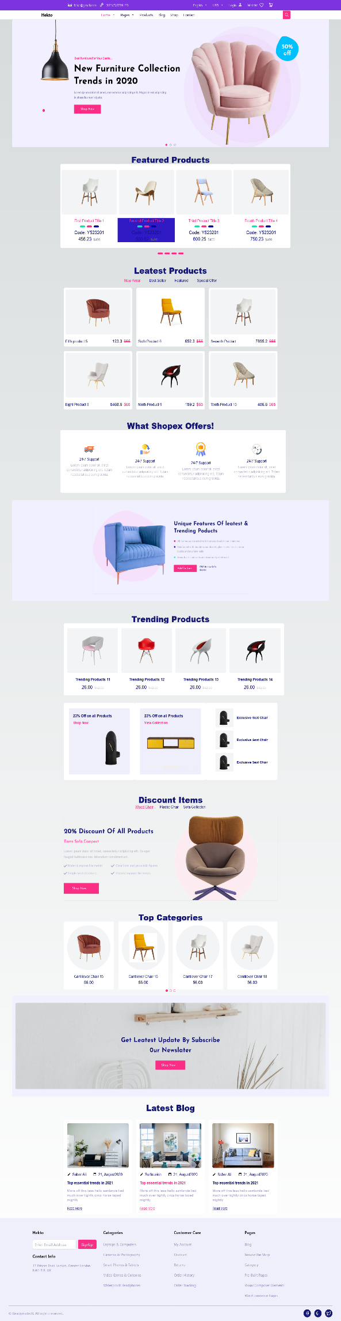

**About Us**

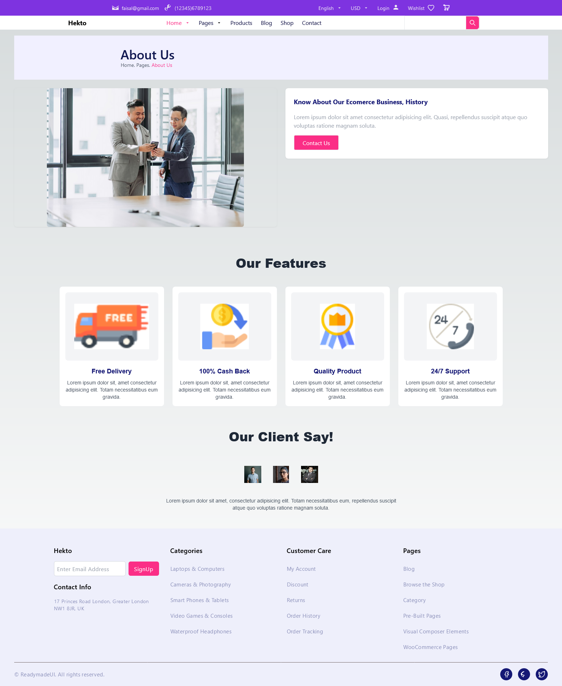

**Blog Page**

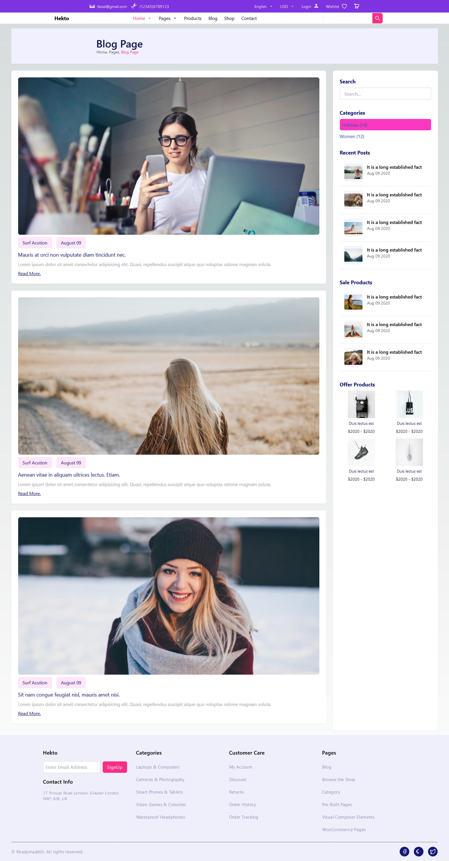

**Blog Single Page**

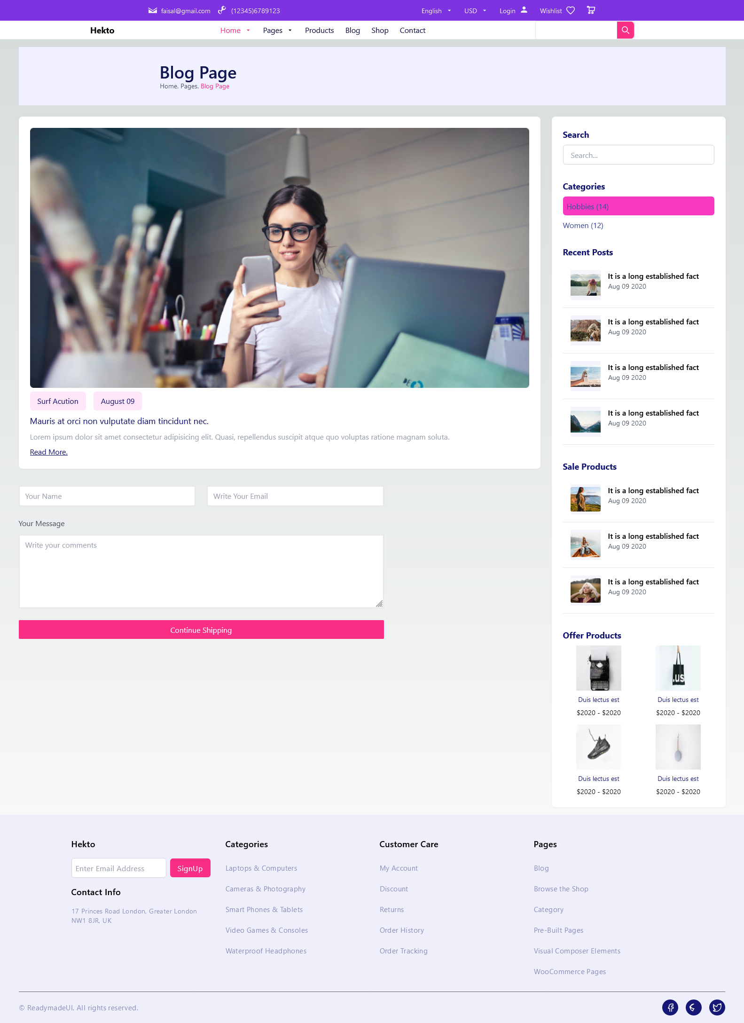

**Cart Page**

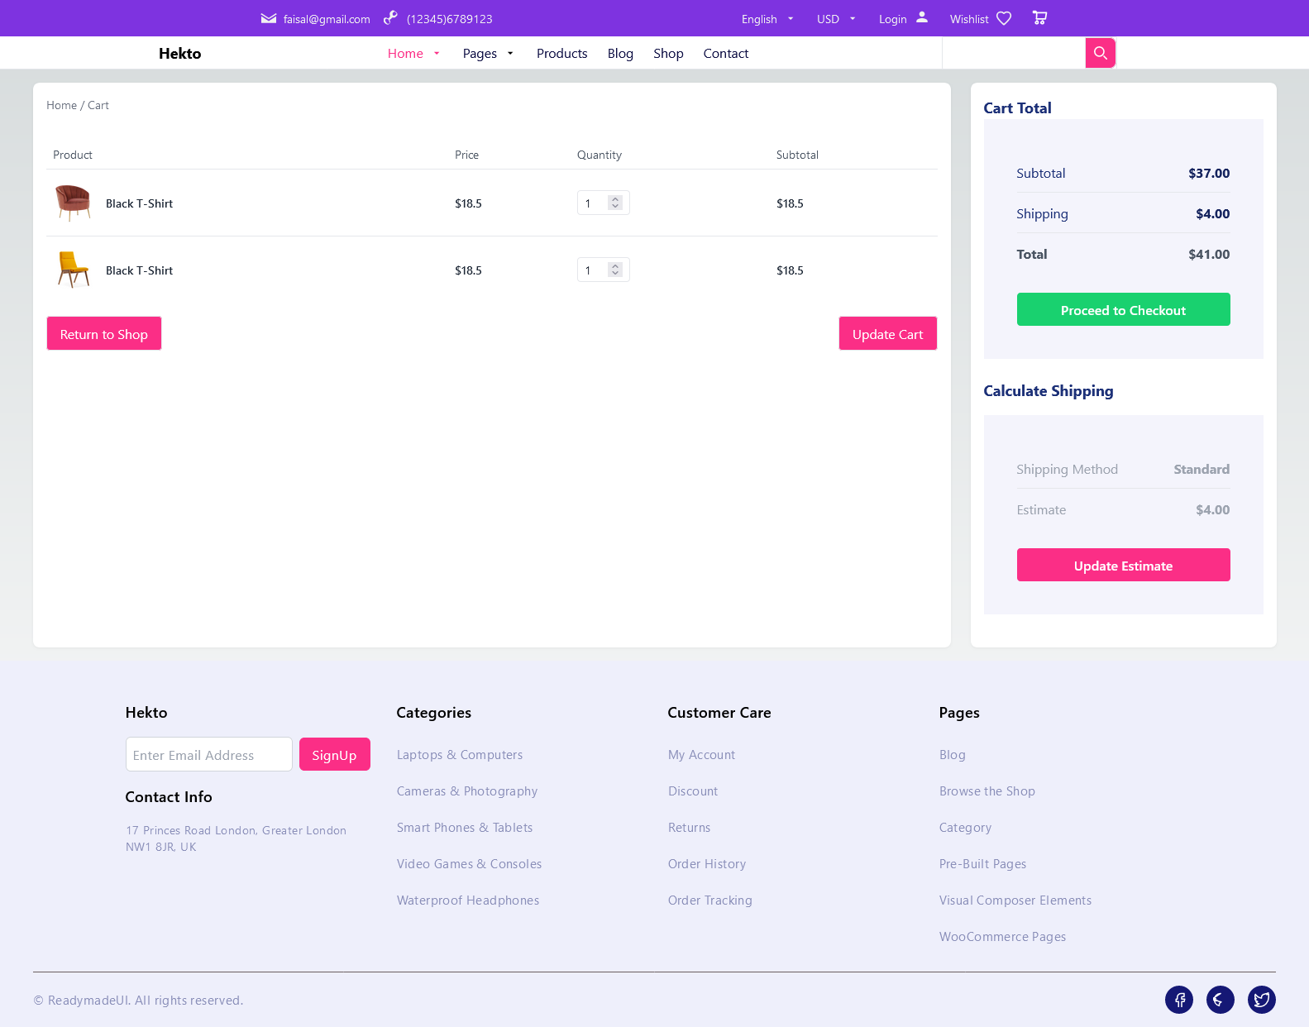

**Checkout Page**

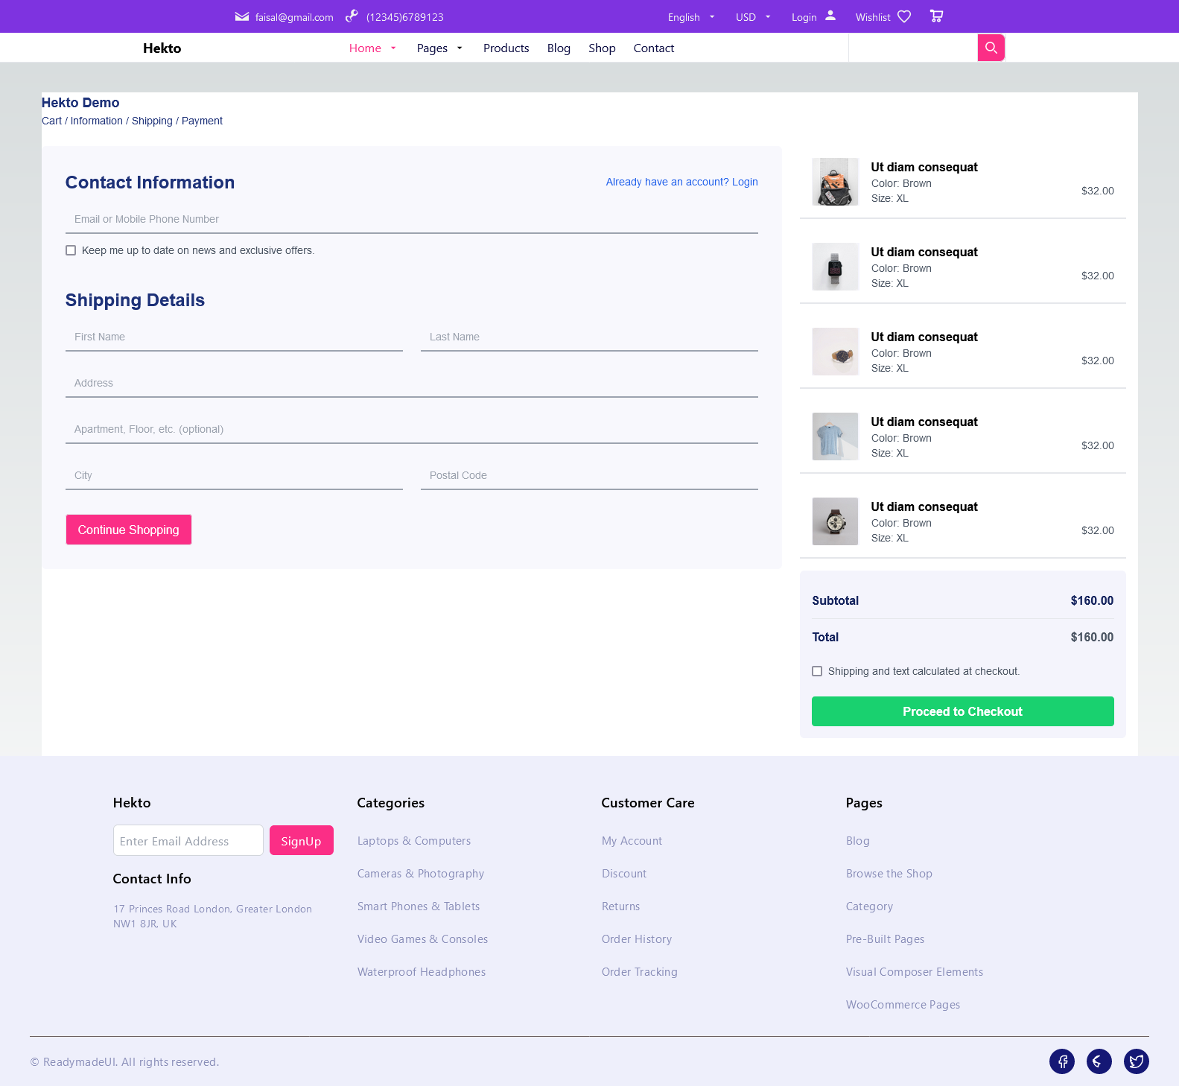

**Contact Us Page**

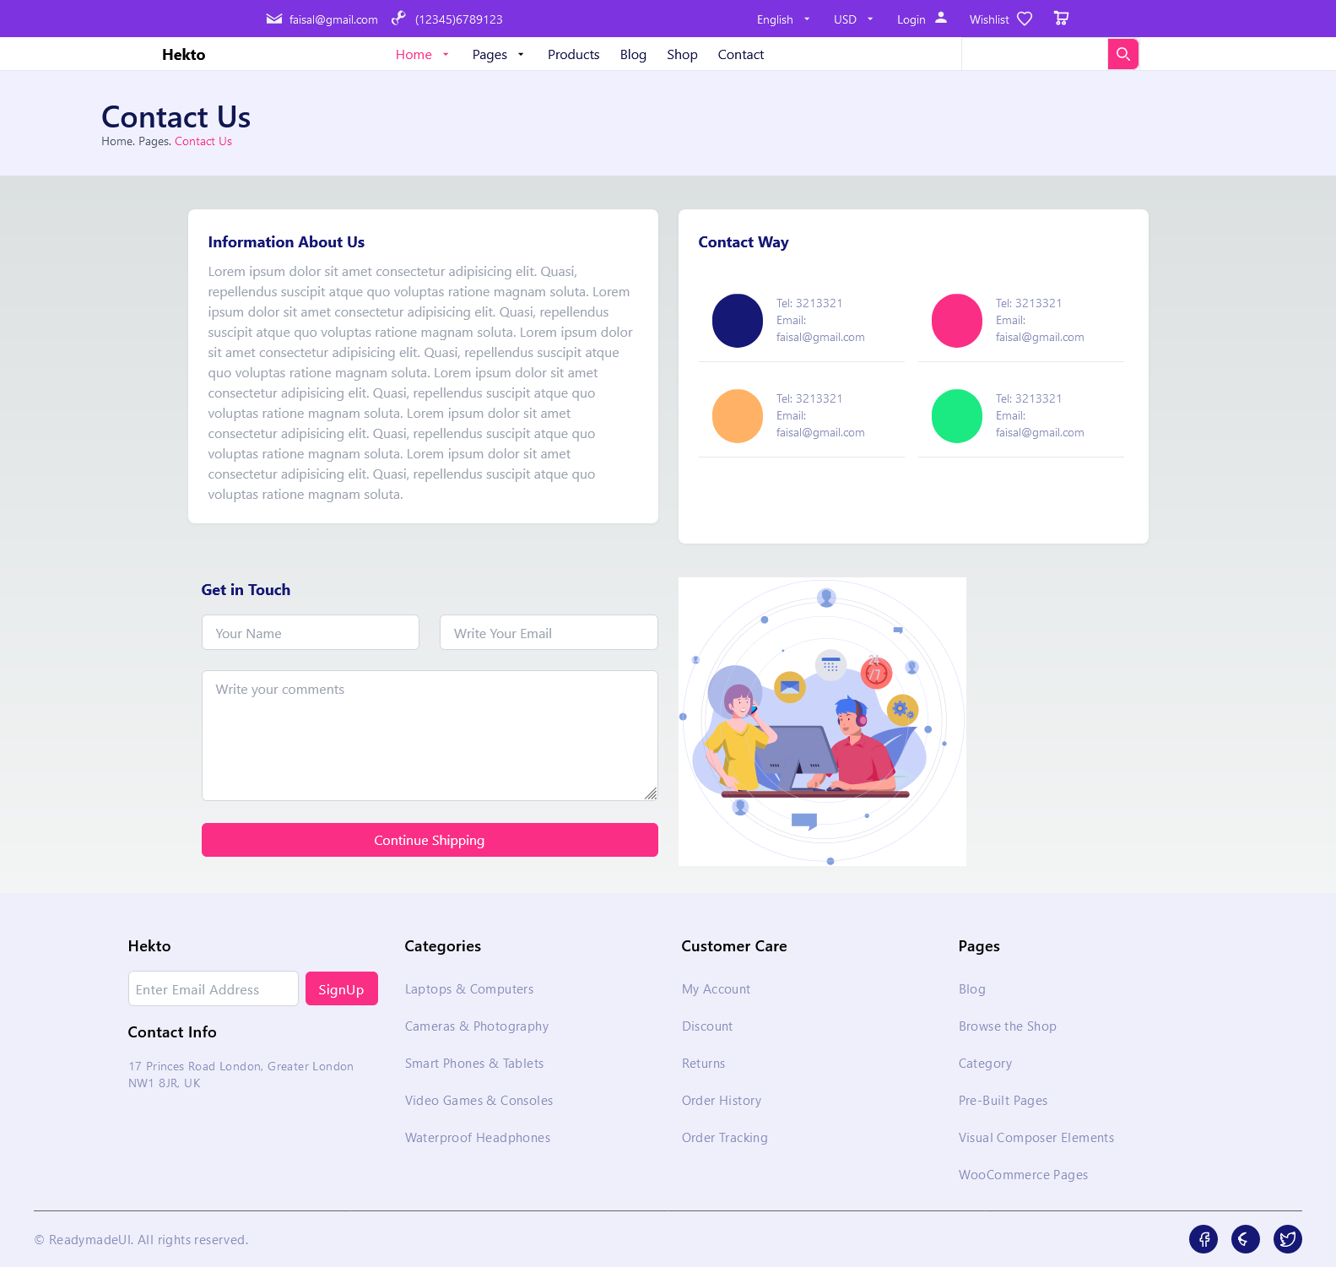

**Faq Page**

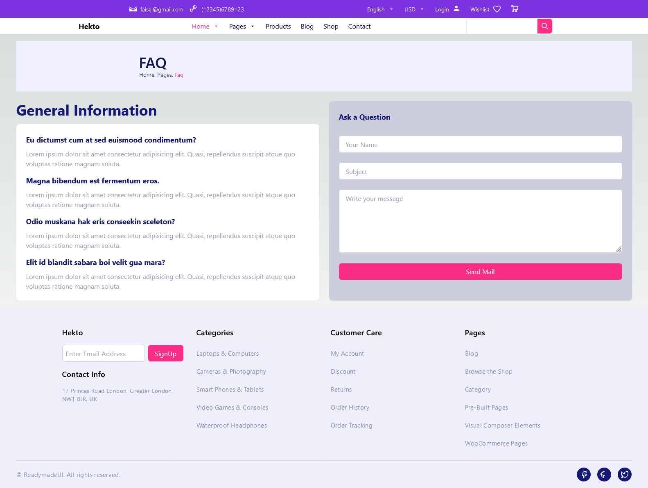

**Login Page**

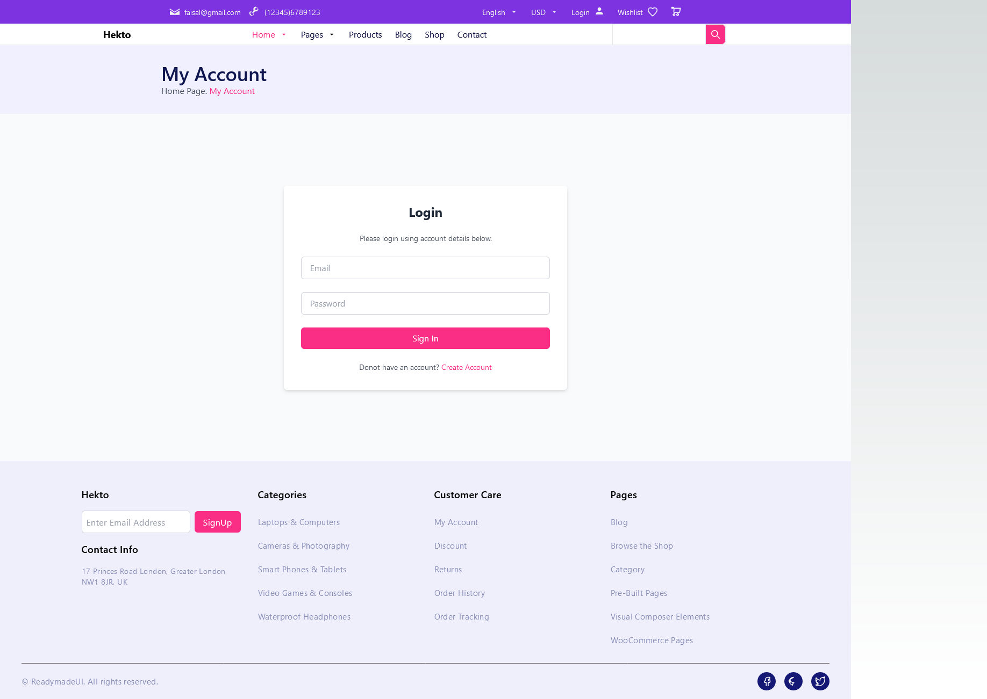

**Not Found 404 Page**

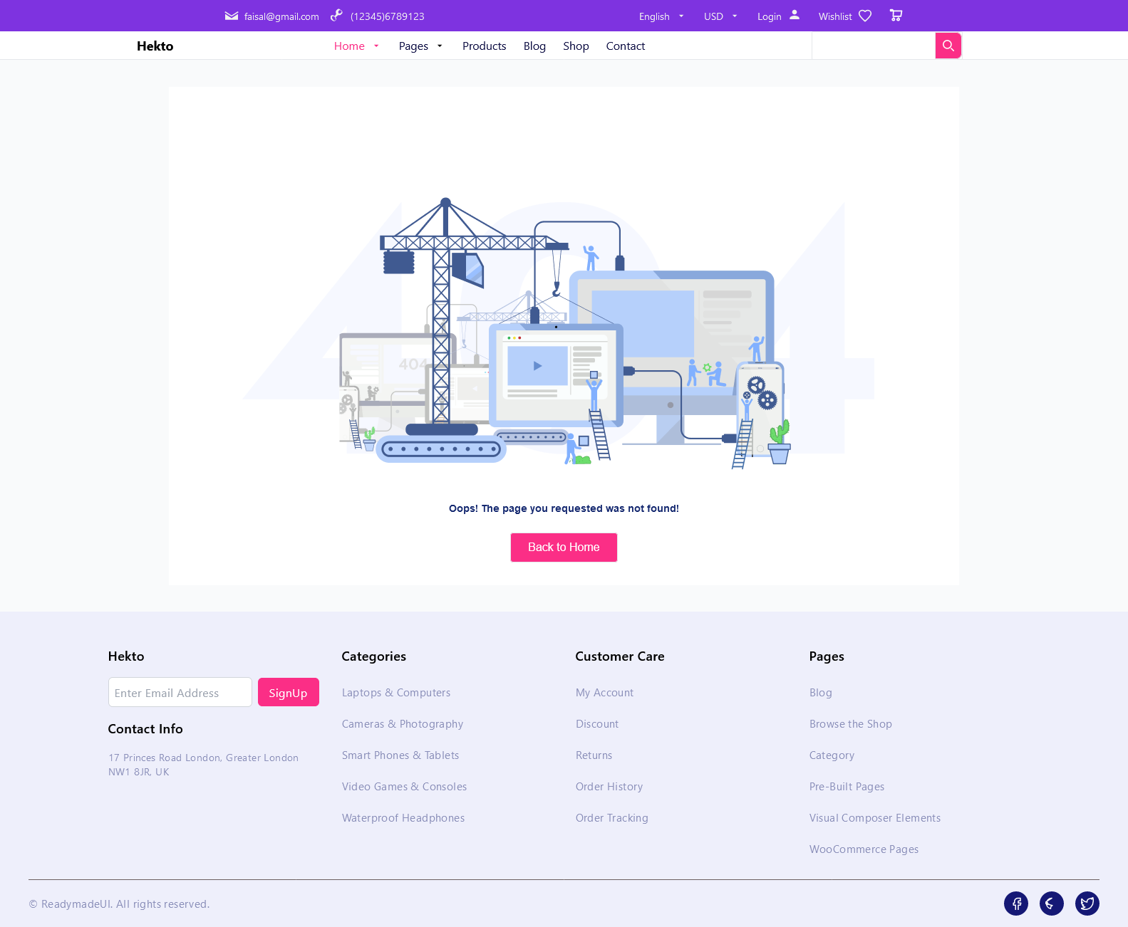

**Order Completed Page**

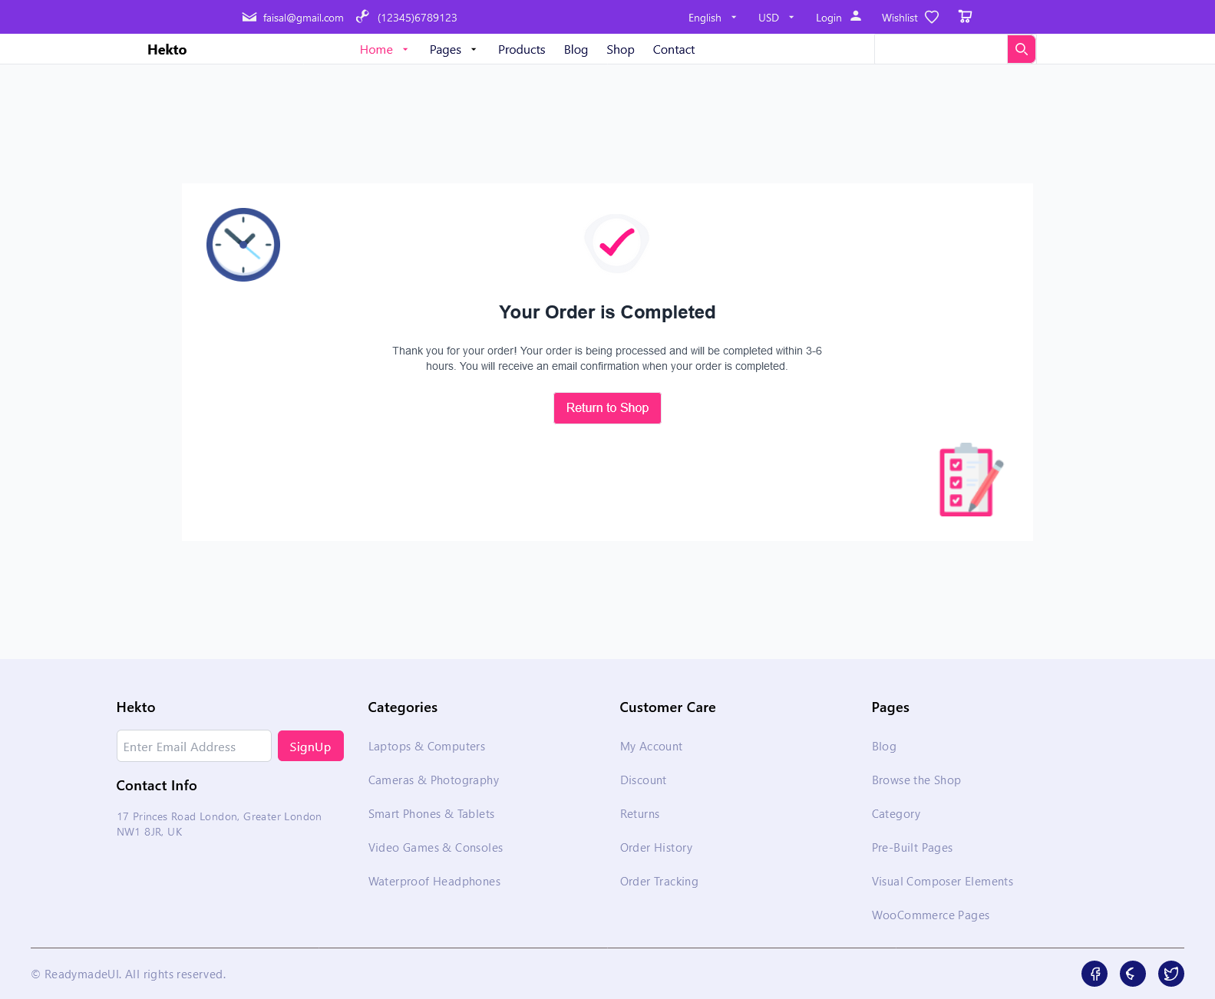

**Product Detail Page**

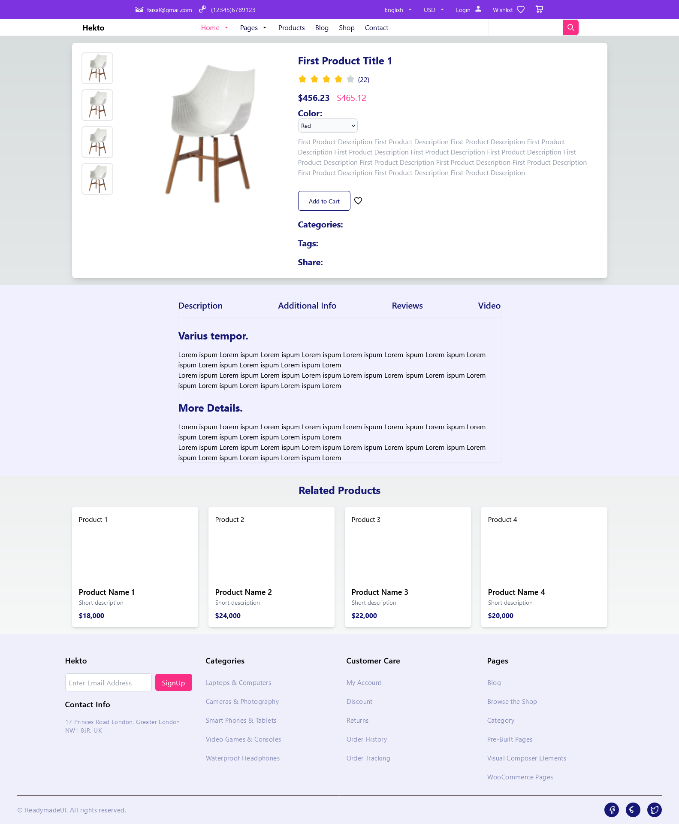

**Shop Grid Page**

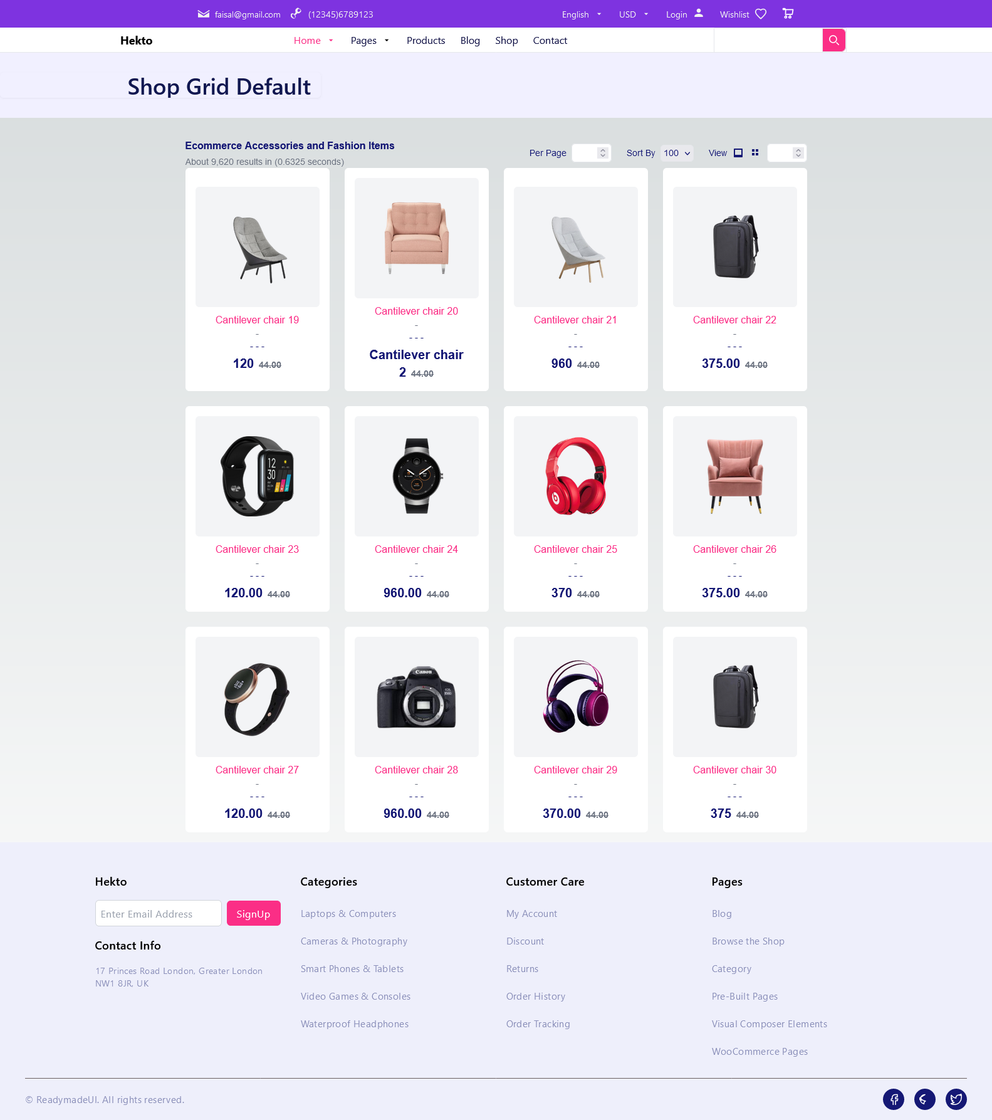

**Shop Left Sidebar**

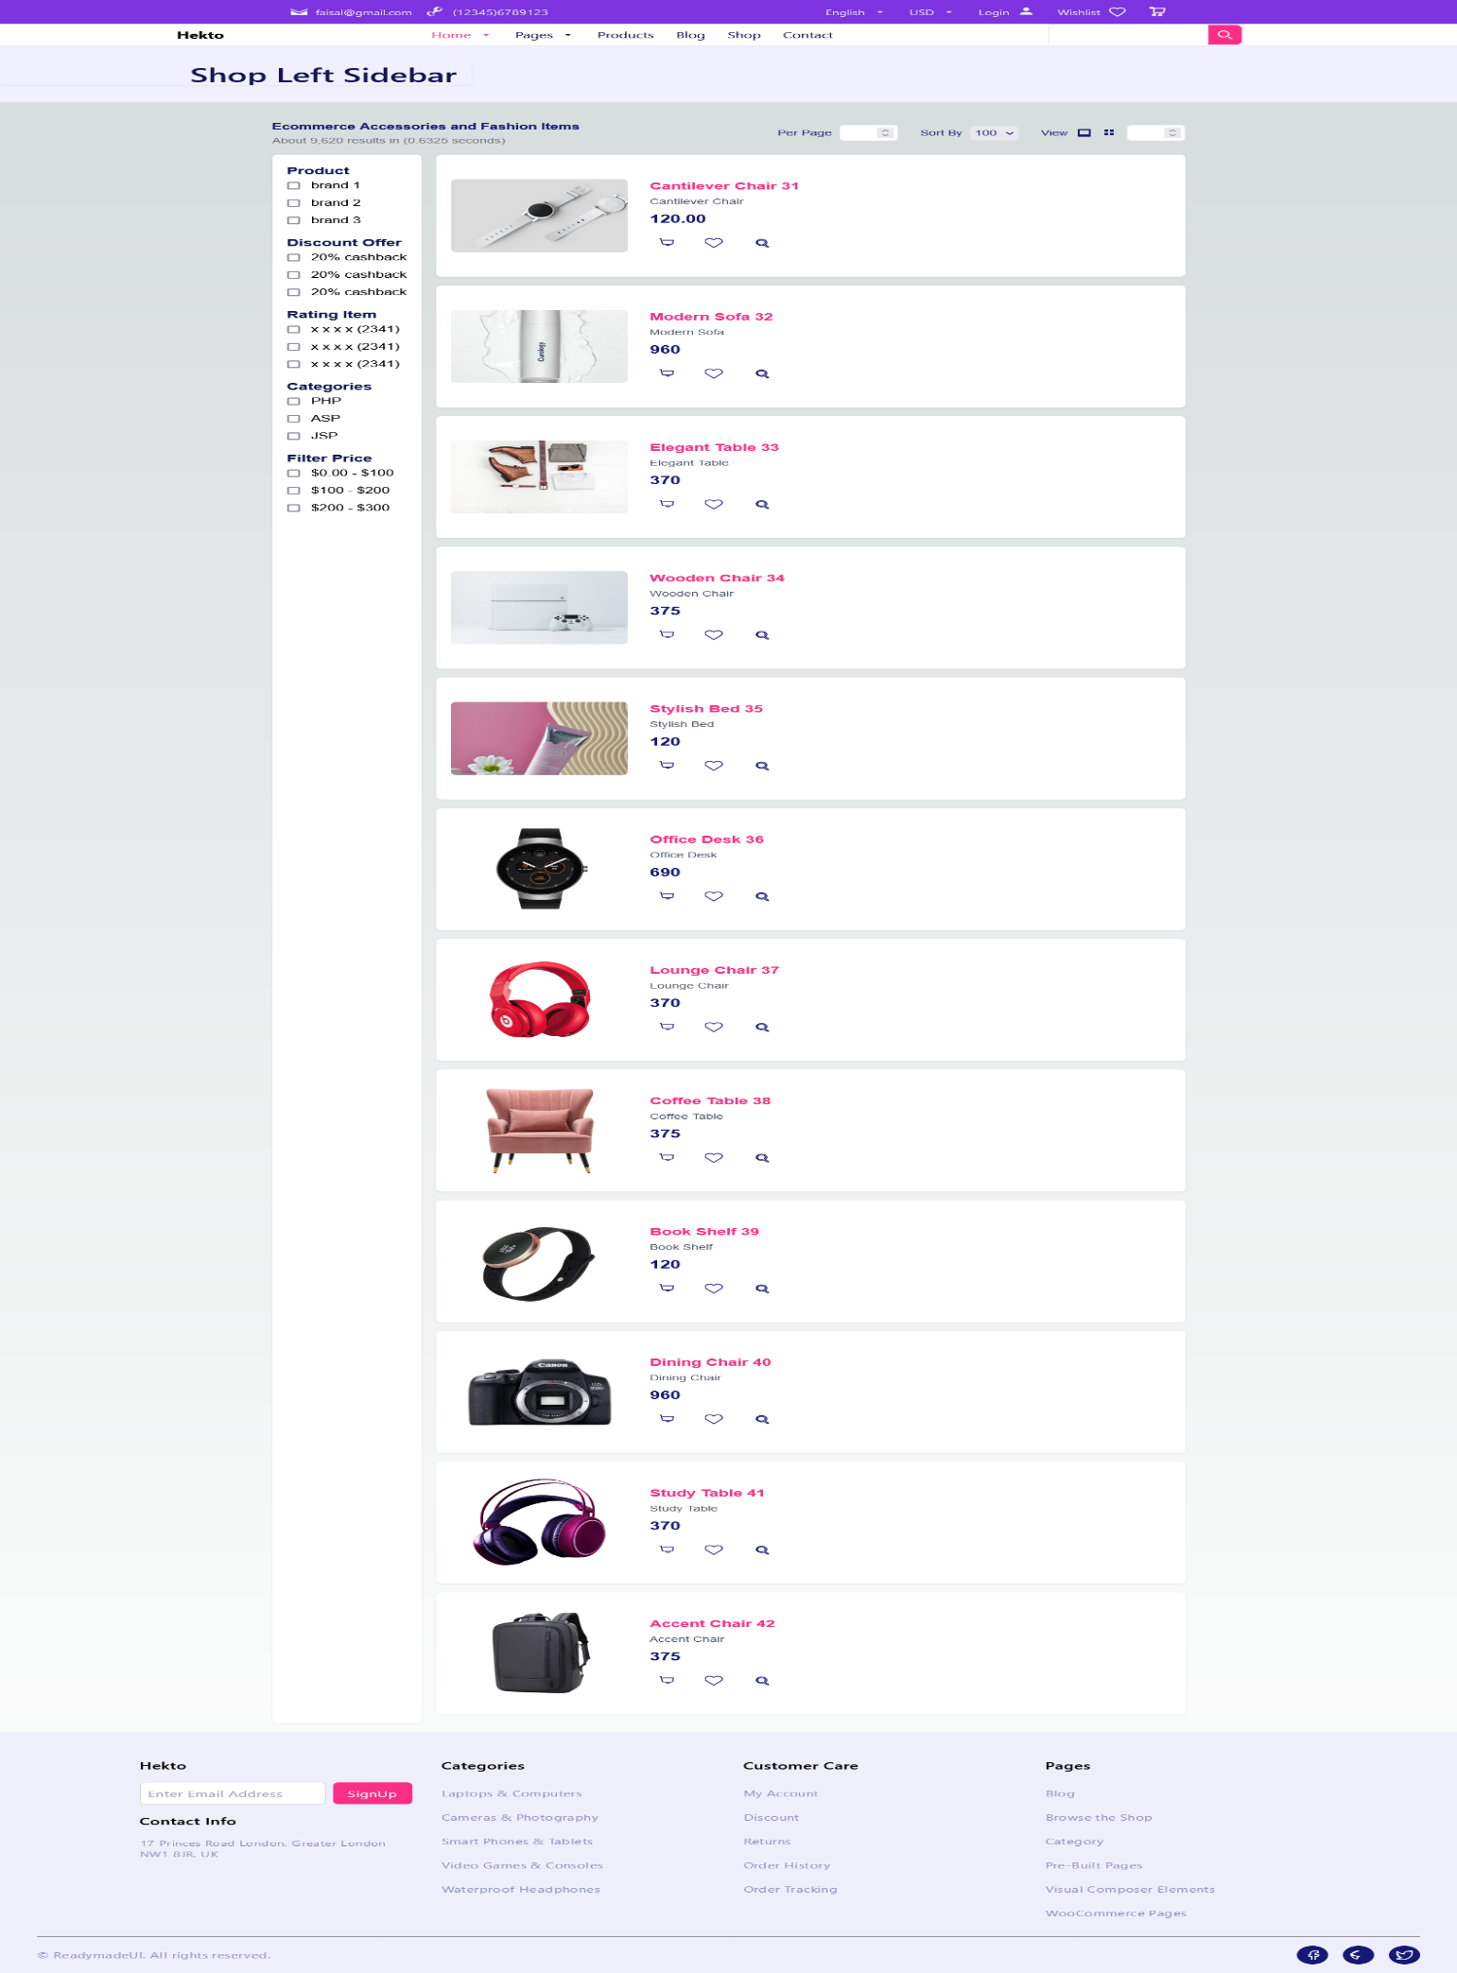

**Shop List Page**

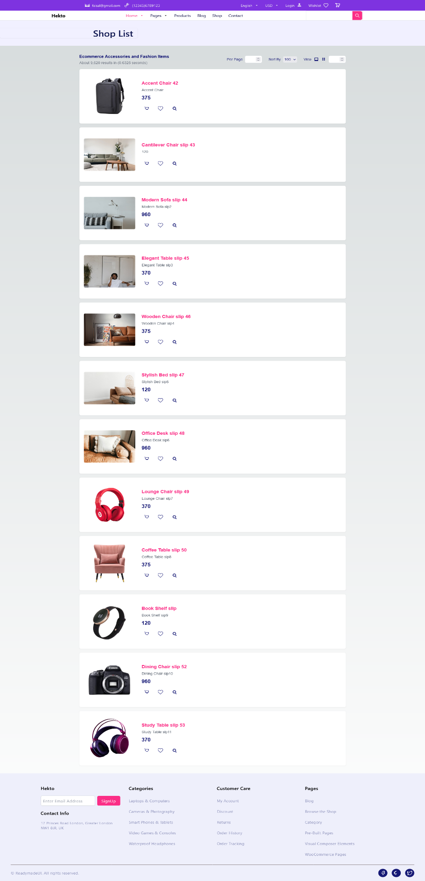

**Checklist for Day 5**:

Functional Testing: ✔

Error Handling: ✔

Performance Optimization: ✔

Cross-Browser and Device Testing: ✔

Security Testing: ✔

Documentation: ✔

Final Review: ✔